# PCOS DETECTION USING DEEP LEARNING

Masters of Technology degree in Data Science

by

**AMULYA LOLADHATTU (2023005720)**



# DEPARTMENT OF COMPUTER SCIENCE AND ENGINEERING

# DATA SCIENCE

Home

**GANDHI INSTITUTE OF SCIENCE TECHNOLOGY AND MANAGEMENT**

**(DEEMED TO BE UNIVERSITY)**

**Accredited with Grade “A++” by NAAC**

**Gandhi Nagar,Rushikonda,VISAKHAPATNAM - 530045**

# MARCH – 2024

0

**DEPARTMENT OF COMPUTER SCIENCE AND**

**ENGINEERING**

**BONAFIDE CERTIFICATE**

This is to certify that this Project Report is the bonafide work of **AMULYA LOLADHATTU (2023005720)** who carried out the project entitled “**PCOS Detection using Deep Learning** ” under our supervision from **DECEMBER 2023 to March 2024**.

Dr.

**Guide**

Dr. ,

**Head of the Department**

**Internal Examiner External Examiner**

# DECLARATION

I **Amulya Loladhattu (2023005720)** hereby declare that the Project Report entitled “**PCOS Detection using Deep Learning**” done by me under the guidance of Dr. **R**, M.E., Ph.D., Department of Biomedical Engineering is submitted in partial fulfillment of the requirements for the award of Bachelor of Technology degree in Biomedical Engineering.

# DATE: 18-03-2024

**PLACE: Visakhapatnam SIGNATURE OF THE CANDIDATE**

# ACKNOWLEDGEMENT

We are pleased to acknowledge our sincere thanks to the **Board of Management of GITAM** for their kind encouragement in doing this project and for completing it successfully. We are grateful to them.

We convey our thanks to Dr. **T.., Head of the Department, Department of Computer Science and Engineering** for providing us necessary support and details at the right time during the progressive reviews.

We would like to express our sincere and deep sense of gratitude to our Project Guide Dr**.D., Department of Computer Science and Engineering** for her valuable guidance, suggestions, and constant encouragement that paved way for the successful completion of our project work.

We wish to express our thanks to all **Teaching and Non-teaching** staff members of the **Department of CSE** who were helpful in many ways for the completion of the project.

# Abstract

Polycystic ovary syndrome (PCOS) is an abnormality in which the androgen level (male sex hormone) in women becomes aberrant, that are commonly present in small amount. The name polycystic ovary syndrome terms the numerous small cysts (fluid- filled sacs) that form in the ovaries. Polycystic ovary syndrome is the most common endocrine disorders in women. Earlier prediction of PCOS will be beneficial eliminating most health issues like irregular menstrual cycle, infertility and hypothyroidism. Hence the proposed work predicts the presence of PCOS from the ultrasonic scanned images. Efficient deep learning techniques are used to predict the presence of PCOS in women at early stage that will lead to effectively save the patient from facing various risk factors. A web application will be developed to easily input the images and get the results. Comparative analysis is performed to assess the effectiveness of the deep learning algorithms like GoogLeNet and ResNet. Thus, this will help in predicting the presence of disease at the earliest.

# TABLE OF CONTENTS

|  |  |  |
| --- | --- | --- |
| **CHAPTER NO** | **TITLE** | **PAGE**  **NO.** |
|  | **ABSTRACT** | i |
|  | **LIST OF ABBREVIATIONS** | v |
|  | **LIST OF FIGURES** | vi |
| 1 | **INTRODUCTION** | 1 |
|  | 1.1 GENERAL INTRODUCTION | 1 |
|  | 1.2 TECHNOLOGIES USED | 2 |
|  | 1.2.1 Deep Learning | 2 |
| 2 | **LITERATURE SURVEY** | 9 |
| **3** | **AIM AND SCOPE** | 13 |
|  | 3.1 AIM OF THE PROJECT | 13 |
|  | 3.2 EXISTING SYSTEM | 13 |
|  | 3.3 DISADVANTAGES OF EXISTING SYSTEM | 13 |
|  | 3.4 PROPOSED SYSTEM | 14 |
|  | 3.5 ADVANTAGES OF PROPOSED SYSTEM | 14 |

|  |  |  |
| --- | --- | --- |
|  | 3.6 SYSTEM ARCHITECTURE | 15 |
|  | 3.7 WORKING | 15 |
|  | 3.8 SCOPE OF THE PROJECT | 16 |
| **4** | **MATERIALS AND METHODS - SYSTEM ANALYSIS** | 17 |
|  | 4.1 MODULE DESCRIPTION | 17 |
|  | 4.1.1 PCOS Dataset Collection | 17 |
|  | 4.1.2 Dataset Pre-processing | 19 |
|  | 4.1.3 Dataset Augmentation | 20 |
|  | 4.1.4 Deep Learning Algorithm training | 21 |
|  | 4.1.4.1 GoogLeNet | 21 |
|  | 4.1.4.2 GoogLeNet Modified | 22 |
|  | 4.1.4.3 ResNet | 22 |
|  | 4.1.4.4 ResNet Modified | 23 |
|  | 4.1.5 Comparison of algorithm | 23 |
|  | 4.1.6 Prediction of disease | 24 |
|  | 4.2 SOFTWARE DESCRIPTION | 25 |
|  | 4.2.1 VISUAL STUDIO | 25 |
|  | 4.2.2 PYTHON | 26 |
| **5** | **RESULTS AND DISCUSSION** | 27 |
|  | 5.1 RESULTS OBTAINED | 27 |
| **6** | **SUMMARY AND CONCLUSION** | 38 |

|  |  |
| --- | --- |
| 6.1 SUMMARY | 38 |
| 6.2 CONCLUSION | 38 |
| 6.3 FUTURE WORK | 39 |
| REFERENCES | 40 |

**LIST OF ABBREVIATIONS**

|  |  |
| --- | --- |
| PCOS | Polycystic ovary syndrome |
| RNNS | Recurrent Neural Networks |
| CNN | Convolutional Neural Networks |
| KNN | K-Nearest Neighbors |
| ANN | Artificial Neural Network |
| ABUS | Automated Breast Ultrasound |
| LSTM | Long Short-Term Memory |
| ResNet | Residual Network |

**LIST OF FIGURES**

|  |  |  |
| --- | --- | --- |
| **FIGURE**  **NO** | **NAME OF THE FIGURE** | **PAGE**  **NO.** |
| 1.1 | Deep Learning Layers | 2 |
| 1.2 | Deep Learning Process | 3 |
| 1.3 | Types of Deep Learning Networks | 5 |
| 1.4 | CNN | 7 |
| 1.5 | Types of CNN | 8 |
| 3.1 | Proposed System Architecture | 15 |
| 4.1 | Dataset collected image | 18 |
| 4.2 | Dataset Pre-processing | 19 |
| 4.3 | Dataset Augmentation | 20 |
| 4.4 | GoogLeNet architecture | 22 |
| 4.5 | ResNet architecture | 23 |
| 4.6 | Comparison of algorithm | 24 |
| 5.1 | Dataset Collected | 27 |
| 5.2 | Dataset Augmentation | 28 |
| 5.3 | Simple Pre-processing | 28 |
| 5.4 | Image to Array Pre-processing | 29 |
| 5.5 | Aspect Aware Pre-processing | 29 |
| 5.6 | Classification report of ResNet model | 30 |
| 5.7 | Training and validation loss graph | 30 |

|  |  |  |
| --- | --- | --- |
| 5.8 | Training and validation accuracy graph | 31 |
| 5.9 | Classification report of Modified ResNet model | 31 |
| 5.10 | Training and validation loss graph | 32 |
| 5.11 | Training and validation accuracy graph | 32 |
| 5.12 | Classification report of GoogLeNet model | 33 |
| 5.13 | Training and validation loss graph | 33 |
| 5.14 | Training and validation accuracy graph | 34 |
| 5.15 | Classification report of Modified GoogLeNet model | 34 |
| 5.16 | Training and validation loss graph | 35 |
| 5.17 | Training and validation accuracy graph | 35 |
| 5.18 | Absence of PCOD detection | 36 |
| 5.19 | Presence of PCOD detection | 36 |
| 5.20 | Comparison between accuracy, recall, precision and F1 score of modified GoogLeNet and modified ResNet | 37 |

# CHAPTER 1 INTRODUCTION

* 1. GENERAL INTRODUCTION:

PCOS (polycystic ovarian syndrome) is a hormonal condition that affects many women of reproductive age. Women with PCOS may have irregular or prolonged menstrual cycles, as well as high levels of the male hormone androgen. The ovaries may produce a large number of tiny collections of fluid (follicles) and fail to release eggs on a regular basis. PCOS's actual cause is uncertain. Early detection and treatment, as well as weight loss, can help to lower the risk of long-term problems like type 2 diabetes and heart disease.

PCOS signs and symptoms usually appear around the time of puberty's first menstrual period. PCOS can develop later in life, for example, as a result of significant weight gain. Menstrual cycles that are infrequent, irregular, or protracted are the most common symptom of PCOS. Excess face and body hair (hirsutism), as well as severe acne and male-pattern baldness, can all be symptoms of elevated male hormone levels. The ovaries may be enlarged, with follicles around the eggs. As a result, the ovaries may stop working properly.

Insulin is a hormone generated by the pancreas that helps cells to consume sugar, which is our body's main source of energy. Our blood sugar levels can rise and our bodies may produce more insulin if our cells grow resistant to the effects of insulin. Excess insulin may boost testosterone production, making ovulation problematic. The synthesis of chemicals by white blood cells to fight infection is referred to as low-grade inflammation. Women with PCOS have a form of low-grade inflammation that causes their polycystic ovaries to create androgens, which can cause heart and blood vessel problems, according to research. Certain genes have been related to PCOS, according to research. Hirsutism and acne are caused by unusually high quantities of androgen produced by the ovaries.

Birth control tablets to regulate periods, metformin to avoid diabetes, statins to reduce high cholesterol, hormones to improve fertility, and surgeries to remove unwanted hair are some of the treatments available.

* 1. TECHNOLOGIES USED:

## Deep Learning

Deep learning is a type of computer software that simulates the brain's network of neurons. It is a subset of machine learning and is referred to as deep learning since it employs deep neural networks.

Connected layers are used to build deep learning systems.

* + - * The first layer is called the Input Layer
      * The last layer is called the Output Layer
      * All layers in between are called Hidden Layers. The word deep means the network join neurons in more than two layers.

[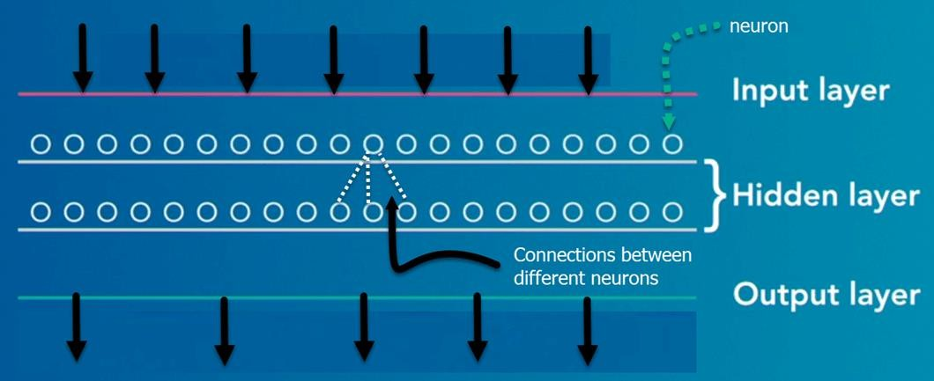](https://www.guru99.com/images/tensorflow/083018_0542_WhatisDeepl1.png)

## Fig: 1.1: Deep Learning Layers

Neurons make up each of the Hidden layers. The neurons are all linked together. The input signal received by the layer above the neuron will be processed and then propagated by the neuron. The weight, bias, and activation function all influence the strength of the signal sent to the neuron in the following layer.

The network absorbs vast amounts of incoming data and processes it across numerous layers, with each layer learning increasingly complicated data properties.

Importance of deep learning?

Deep learning is a great tool for turning a forecast into a useful outcome. Pattern discovery (unsupervised learning) and knowledge-based prediction are two areas where deep learning shines. Deep learning is powered by big data. When these two factors are coupled, a company can achieve extraordinary levels of productivity, sales, management, and creativity. Traditional methods can be outperformed by deep learning. Deep learning algorithms, for example, are 41% more accurate in picture classification than machine learning algorithms, 27% more accurate in facial recognition, and 25% more accurate in voice recognition.

Deep learning process

From object detection to speech recognition, a deep neural network provides state-of- the-art accuracy in a variety of applications. They can learn on their own, without the programmers having to explicitly code predetermined information.

[](https://www.guru99.com/images/tensorflow/083018_0542_WhatisDeepl2.png)

## Fig: 1.2: Deep Learning Process

Consider a household with an infant and parents to grasp the concept of deep learning. With his little finger, the youngster points to items and repeats the phrase 'cat.' Because

his parents are concerned about his education, they continually inform him, "Yes, it is a cat" or "No, that is not a cat." The infant continues to point to items, but with 'cats,' he becomes more precise. Deep down, the tiny kid doesn't understand why he can say if it's a cat or not. He has only recently learnt how to categorize the various aspects of a cat by looking at the creature overall and then focusing on details such as the tails or the nose before making a decision. A neural network works in a similar way. The hierarchy of knowledge is represented by each layer, which indicates a deeper level of information. A four-layer neural network will learn more complex features than a two- layer neural network.

The learning occurs in two phases.

* + - * The first phase consists of applying a nonlinear transformation of the input and create a statistical model as output.
      * The second phase uses a mathematical method called as derivative to improve the model.

These two processes are repeated hundreds to thousands of times until the neural network reaches a level of accuracy that is acceptable. Iteration refers to the repetition of this two-phase process.

Neural network classification

Shallow neural network: Between the input and output, there is just one hidden layer in a shallow neural network.

The term "deep neural network" refers to a network that has more than one layer. For example, the GoogLeNet image recognition model has 22 layers.

Deep learning is now employed in a variety of applications, including autonomous cars, mobile phones, Google Search Engine, fraud detection, television, and so on.

[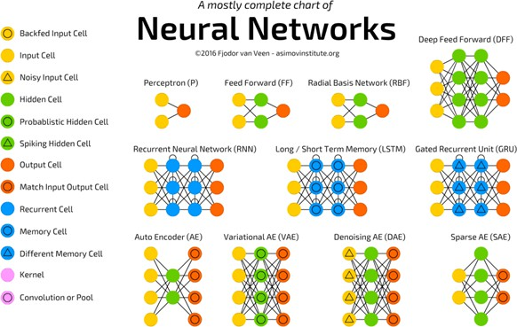](https://www.guru99.com/images/tensorflow/083018_0542_WhatisDeepl3.png)

## Fig: 1.3: Types of Deep Learning Networks

Feed-forward neural networks:

Artificial neural networks in their most basic form. Information moves in only one direction, forward, with this design. It indicates that data flows begin at the input layer, continue through the "hidden" levels, and finally conclude at the output layer. There is no loop in the network. The output layers are where the information comes to a halt.

Recurrent neural networks (RNNS):

RNN is a multi-layered neural network that can learn data sequences and output a number or another sequence by storing information in context nodes. In layman's terms, it's an artificial neural network with looped connections between neurons.

The RNN neurons will get a signal pointing to the start of the sentence, which is well suited for processing sequences of inputs.

The network takes the word "Do" as an input and outputs a number vector. This vector is given back to the neuron, giving the network a memory. This stage assists the network in remembering that it received "Do" in the first position.

The network will go to the next words in the same manner. It is based on the word "You" and "Wish" are two words that come to mind. Each time a word is received, the status of the neurons is modified.

After receiving the word, the final stage occurs "1. For each English word that can be used to finish the sentence, the neural network will return a likelihood. "Café," "drink," "burger," and other words with high probabilities are likely to be assigned by a well- trained RNN.

Common uses of RNN:

* + - * Assist securities traders in producing analytic reports.
      * Detect anomalies in financial statement contracts.
      * Detect fraudulent credit-card transaction.
      * Add a caption to each photograph Bots with a lot of punch.
      * Power chatbots
      * The standard uses of RNN occur when the practitioners are working with time- series data or sequences (e.g., audio recordings or text).

Convolutional neural networks (CNN):

CNN is a multi-layered neural network with a unique architecture designed to extract increasingly complex features of the data at each layer to determine the output. CNNs are well suited for perceptual tasks.

[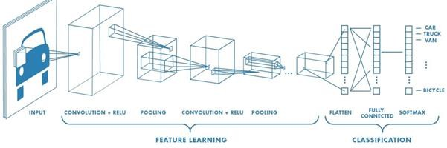](https://www.guru99.com/images/tensorflow/083018_0542_WhatisDeepl5.png)

## Fig: 1.4: CNN

CNN is mostly used when there is an unstructured data set (e.g., images) and the practitioners need to extract information from it.

If the aim is to predict the caption of an image, for example:

* Let's say CNN receives a picture of a cat; this picture is a collection of pixels in computer terms. A greyscale image usually has one layer, while a color image has three layers.
* The network will recognize distinctive features, such as the tail of the cat, the ear, and so on, during the feature learning (i.e., hidden layers) phase.
* When the network has mastered the art of image recognition, it can assign a probability to each image it has encountered. The network's forecast is determined by the label with the highest probability.

A Convolutional Neural Network (CNN, or ConvNet) is a type of multi-layer neural network that is meant to recognise visual patterns directly from pixel images with little or no pre-processing. The ImageNet project is a vast visual database created to aid in the development of visual object recognition software. The ImageNet project hosts an annual software competition called the ImageNet Large Scale Visual Recognition Challenge (ILSVRC), in which software programmes compete to classify and recognise objects and scenes properly. In this article, I'll discuss the CNN

architectures of ILSVRC's leading competitors.

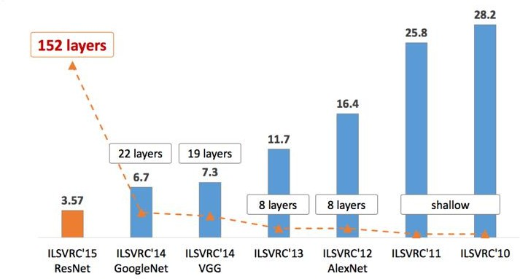

***Fig: 1.5: Types of CNN***

# CHAPTER - 2 LITERATURE SURVEY

Rachana et al., (2021) did a project on Detection of Polycystic Ovarian Syndrome Using Follicle Recognition Technique. An automatic PCOS diagnosing tool would help to save the actual time spent on manual tracing of follicles and measuring the geometric features of every follicle. The proposed method was able to achieve classification with greater accuracy using a KNN classifier.

Chunyu Wang et al., tried Follicles Classification to Detect Polycystic Ovary Syndrome Using Glcm and Novel Hybrid Machine Learning. For follicles abnormal and normal classification, an artificial neural network (ANN) technique with Improved Fruit Fly Optimization (IFFOA) is proposed in this work and named as (IFFOA-ANN) that avoids those risks. In this technique, for enhancing image quality, input ultrasound images are resized and noise in it are removed. Then, adaptive k-means clustering technique is used for processing follicles segmentation. In addition, statistical GLCM is used for introducing feature extraction model. At last, for classification, ANN will be trained using these features. With respect to accuracy, recall and precision, proposed model’s effectiveness is demonstrated in experimental results.

Vikas et al., (2021) did a project on Detection of Polycystic Ovarian Syndrome using Convolutional Neural Networks. To assist in the diagnosis of PCOS, deep learning methods such as Convolutional Neural Networks can be applied which produce effective results in image classification tasks. The accuracies and other performance metrics of prior mentioned deep learning methods are compared and the problem of Over-fitting is discussed. The main motto of using these deep learning methods is to precisely prognosticate whether a person is expected to have PCOS or not.

Shekoofeh Azizi et al., (2018) developed a project on Deep Recurrent Neural Networks for Prostate Cancer Detection: Analysis of Temporal Enhanced Ultrasound. In this paper, we propose to use deep recurrent neural networks (RNN) to explicitly model the temporal information in TeUS. By investigating several RNN models, we demonstrate

that long short-term memory (LSTM) networks achieve the highest accuracy in separating cancer from benign tissue in the prostate. We also present algorithms for in-depth analysis of LSTM networks.

Wenfeng Song et al., (2015) did Multi-task Cascade Convolution Neural Networks for Automatic Thyroid Nodule Detection and Recognition. Thyroid ultrasonography is a widely-used clinical technique for nodule diagnosis in thyroid regions. However, it remains difficult to detect and recognize the nodules due to low contrast, high noise, and diverse appearance of nodules. In today’s clinical practice, senior doctors could pinpoint nodules by analyzing global context features, local geometry structure, and intensity changes, which would require rich clinical experience accumulated from hundreds and thousands of nodule case studies. To alleviate doctors’ tremendous labor in the diagnosis procedure, we advocate a machine learning approach to the detection and recognition tasks in this paper. In particular, we develop a multi-task cascade convolution neural network framework (MCCNN) to exploit the context information of thyroid nodules. It may be noted that, our framework is built upon a large number of clinically-confirmed thyroid ultrasound images with accurate and detailed ground truth labels. Other key advantages of our framework result from a multi-task cascade architecture, two stages of carefully-designed deep convolution networks in order to detect and recognize thyroid nodules in a pyramidal fashion, and capturing various intrinsic features in a global-to-local way. Within our framework, the potential regions of interest after initial detection are further fed to the spatial pyramid augmented CNNs to embed multi-scale discriminative information for fine grained thyroid recognition. The new learning architecture affords the detection and classification tasks to share commonly needed features, with an objective of better distinguishing benign nodules from malignant nodules, as well as the complex background.

Nikhil S. Narayan et al., (2017) studied Speckle Patch Similarity for Echogenicity based Multi-Organ Segmentation in Ultrasound Images of the Thyroid Gland. The usefulness of speckle related pixels and imaging artefacts as sources of information to perform multi-organ segmentation in US images of the thyroid gland. The speckle related pixels are clustered based on a similarity constraint to quantize the image. The quantization

results are used to locate useful anatomical landmarks that aid the detection of multiple organs in the image which are the thyroid gland, the carotid artery, the muscles and the trachea. The spatial locations of the carotid artery and the trachea are used to estimate the boundaries of the thyroid gland in transverse US scans.

Micha Feigin et al., (2020) tried using the Deep Learning Framework for Single-Sided Sound Speed Inversion in Medical Ultrasound. In this paper, we present a single-sided sound speed inversion solution using a fully convolutional deep neural network. We use simulations for training, allowing the generation of limitless ground truth data. We show that it is possible to invert for longitudinal sound speed in soft tissue at high frame rates. We validate the method on simulated data. We present highly encouraging results on limited real data.

Dipamoni Morang et al., (2019) described Polycystic Ovary Syndrome (PCOS). They explain in detail about the PCOS causes, its effect on women and the treatment. Create awareness about PCOS, its early detection can cure the disease.

Connor Shorten et al., (2019) took a survey on Image Data Augmentation for Deep Learning. It focuses on data augmentation, a data-space solution to the problem of limited data. Different types of augmentation algorithms are discussed. It shows how data augmentation can improve the performance of their models and expand limited datasets to take advantage of the capabilities of big data.

Kiruthika et al., (2020) applied Machine Learning based ovarian detection in ultrasound images. An intelligent automatic algorithm using Machine learning is developed for ovarian detection and classification. It has increased the efficiency and accuracy of PCOS detection of without misinterpretation and enabling prompt diagnosis and treatment by physicians.

Priyanka Lele et al., (2020) did a Comparative Analysis of Classifiers for Polycystic Ovary Syndrome Detection using Various Statistical Measures. Used machine learning algorithms like multilayer perception, K-star, IB 1 instance-based, locally weighted learning, decision table, M5 rules, Zero R, Random Forest and random tree to classify PCOS. K-star algorithm is out performing in all the performances measure.

Sumathi et al., (2020) developed K-Study and detection of PCOS related diseases using CNN. Performed by CNN based image processing feature extraction to classify cysts in the dataset. Classify test data to know whether ovary is affected and parameters like area, solidity, extent, perimeter where exactly affected.

Bharati et al., (2020) have done a project on Diagnosis of Polycystic Ovary Syndrome Using Machine Learning Algorithms. They have used RFLR (Regression, Hybrid random forest, Logistic regression). It reliably classifying PCOS patients.

Xiangbin Liu et al., (2021) conducted a Review of Deep-Learning-Based Medical Image Segmentation Methods. Medical image segmentation using deep learning like 2D CNN, 3D CNN, deep learning architectures like VGG, ResNet, Alex Net and GoogLeNet. Diagnosing various disease through artificial intelligence realizes the idea of sustainable medical treatment. It becomes a powerful tool for clinicians.

# CHAPTER - 3 AIM AND SCOPE

* 1. AIM OF THE PROJECT:
     + The objective of the project is to effectively automate the prediction of PCOS in ultrasonic images.
     + To increase the accuracy of the existing models. To detect the PCOS at its earlier stage.
     + Deep learning algorithms are used for classification of data.
     + To reduce time of detection
  2. EXISTING SYSTEM

Polycystic ovarian syndrome (PCOS) is a condition characterized by a protracted menstrual cycle and an excess of testosterone in numerous women of reproductive age. Impotence, gynecomastia, and hirsutism are all symptoms of this condition. The study of these conditions in women is a serious issue that may be solved by studying ultrasound images that provide the required details such as the number of follicles, their size, and their location. However, there is a lack of a reliable objective test that can diagnose and interpret PCOS with perfect certainty. This encourages us to consider developing a method for diagnosing PCOS at an early stage in order to avoid subsequent difficulties. An automatic PCOS diagnosis tool would help to reduce the amount of time spent manually tracing follicles and measuring their geometric properties. Using a KNN classifier, the proposed technique was able to obtain classification accuracy of better than 97 percent. The classifier will shorten the time it takes to diagnose PCOS and enhance its accuracy, lowering the danger of deadly consequences that can occur when diagnosis is delayed.

* 1. DISADVANTAGES OF EXISTING SYSTEM
* In the existing system, KNN algorithm is used and the accuracy depends on the quality of the data.
* Only focused on follicles determination to diagnose the PCOS disease.
  1. PROPOSED SYSTEM

PCOS is a condition in which the ovaries create an inordinate level of androgens, male sex hormones that are normally present in tiny amounts in women. The numerous tiny cysts (fluid-filled sacs) that occur in the ovaries are known as polycystic ovarian syndrome. Polycystic ovary syndrome (PCOS) is the most common (and perhaps overlooked) endocrine disorders in women Thyroid abnormalities in PCOS are thought to be caused by both hereditary and environmental causes. Hypothyroidism has been associated to PCOS-like ovaries, as well as general worsening of PCOS and insulin resistance. High thyroid antibody levels in PCOS patients appear to be linked to elevated estrogen and the estrogen/progesterone ratio. The hormones generated by your thyroid are essential for the healthy functioning of all cells in your body. Thyroid hormones govern your heart rate and can impact your menstrual cycle, affecting fertility, in addition to controlling the pace at which your body transforms carbohydrates, protein, and fats into fuel. Earlier prediction of presence of PCOS will be beneficial eliminating most health issues. Hence, in this project we are going to predict the presence of PCOS from the ultrasonic scanned images. Data augmentation and pre- processing techniques are applied to process the datasets. Then, it will be fed for training with the efficient deep learning algorithms such as GoogLeNet and ResNet is used to predict the presence of PCOS in women. The accuracy will be compared for both the algorithms to determine the best accurate algorithm. Then an image will be given as input to diagnose the presence of PCOS disease. Predicting it early will lead to effectively save the patient from facing various risk factors. Thus, this will help in predicting the presence of disease at the earliest.

* 1. ADVANTANGES OF PROPOSED SYSTEM
     + Predicts the presence of the PCOS in ultrasonic images.
     + Saves patient from serious health issues.
     + Provides a practical application to hospitals.
  2. SYSTEM ARCHITECTURE

The architectural diagram is shown in Fig: 3.1

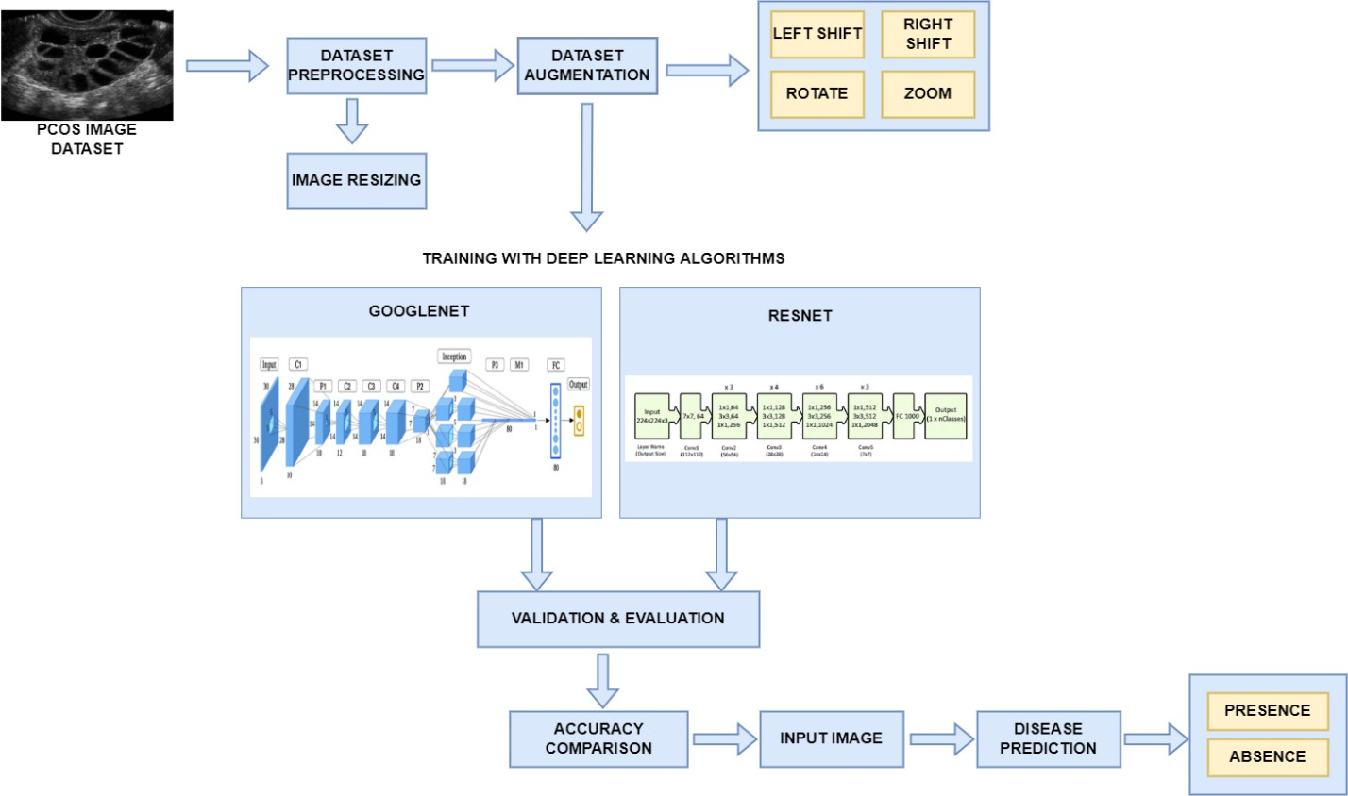

## Fig: 3.1: Proposed System Architecture

* 1. WORKING

In this project, we are going to predict the presence of PCOS from the ultrasonic scanned images by using the Deep Learning algorithms. So, the first step in the project will be collecting the dataset for the PCOS image datasets. After the datasets collected, Data augmentation and pre-processing techniques are applied to process the datasets. Image resizing is used in dataset pre-processing. Then, it will be fed for training with the efficient deep learning algorithms. The algorithms such as GoogLeNet and Resnet kind of algorithms can be compared for increasing the performance of the system to predict the presence of disease. GoogLeNet is a convolutional neural network that is 22 layers deep (27 layers including pooling layers), and part of these layers are a total of 9 inception modules. Residual Network (ResNet) is a well-known deep learning model, and its design includes a 34-layer simple network inspired on VGG-19, to which

shortcut connections or skip connections are added. After applying the Deep Learning algorithms, it will validate and evaluate the datasets. The accuracy will be compared for both the algorithms to determine the best accurate algorithm. Based on the accuracy comparison, an image will be given as input to diagnose the presence of PCOS disease. Predicting it early will lead to effectively save the patient from facing various risk factors. Thus, this project will help in predicting the presence of PCOS disease at the earliest.

* 1. SCOPE OF THE PROJECT
     + It will be used in hospitals.
     + It will be used in lab tests.
     + Accurate detection of PCOD using modified GoogLeNet algorithm.
     + Time taken by the manual detection and its accuracy is reduced.
     + In this we have compared two deep learning algorithms and have modified some properties to reach maximum accuracy.

# CHAPTER – 4

**MATERIALS AND METHODS - SYSTEM ANALYSIS**

* 1. MODULE DESCRIPTION:
* PCOS Dataset Collection
* Dataset Pre-processing
* Dataset Augmentation
* Deep Learning Algorithm training
* Comparison of algorithm
* Prediction of disease

## PCOS Dataset Collection

In this project, we are going to collect the PCOS image dataset and it will be fed for training with the advanced deep learning algorithms The accuracy improves as the dataset size grows. A data set is a set of information. Deep Learning has emerged as the preferred way for tackling a wide range of difficult real-world challenges. It is, without a doubt, the most effective strategy for computer vision jobs. Deep learning's power in computer vision is demonstrated in the image above. With enough training, a deep network can segment and identify the "key points" of every person in an image. These deep learning robots, which have been doing admirably, require a lot of fuel, which is data. Our model performs better when there is more labelled data available. Google has even experimented with the premise of more data leading to greater performance on a massive scale, with a dataset of 300 million records. When deploying a Deep Learning model in a real-world application, data must be constantly fed to continue improving its performance. And, in the deep learning era, data is very well arguably the most valuable resource.

Scraping From the Web:

Because of the amount of human work needed, manually finding and downloading photographs takes a long time. The task probably has some kinds of common objects are to be detected. And so that becomes the keyword for web-scraping. It also becomes the class name for that object. Every *single pixel in the image is required.* It's advisable to use some of the many excellent picture annotation tools that are already available. Can produce pixel labels for segmentation given a basic collection of polygon points around an object. Deep extreme cut is similar to deep extreme cut, except that just the four extreme points around the object are used. This will result in some good segmentation and bounding box labels. Another possibility is to use an image annotation GUI that already exists.

Third-party:

Because data has become such a valuable commodity in the deep learning era, numerous start-ups have begun to offer their own image annotation services, in which they will collect and classify the data. Given a description of what kind of data and annotations needed. Mighty is one that has been doing self-driving car image annotation and has become pretty big in the space were at CVPR 2018 too. Payment AI are less specialized than Mighty AI, offering image annotation for any domain.

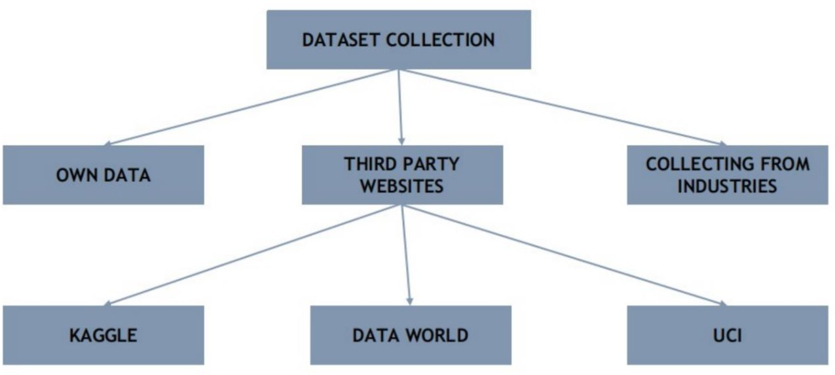

## Fig: 4.1: Dataset collection

* + 1. ***Dataset Pre-processing***

Data pre-processing is a method for transforming raw data into a clean data set. In other words, anytime data is received from various sources, it is collected in raw format, which makes analysis impossible. The network design as well as the input data type must be carefully considered when creating an effective neural network model. The number of images, image height, image width, number of channels, and number of levels per pixel are the most frequent image data input parameters. Typically, there are 3 channels of data corresponding to the colors Red, Green, Blue (RGB) Pixel levels are usually [0,255].

Uniform aspect ratio:

Making ensuring the photographs are the same size and aspect ratio is one of the first things to do. The majority of neural network models assume a square-shaped input image, which means that each image must be evaluated for squareness and cropped accordingly. Cropping can be used to choose a square portion of an image, as illustrated in the example. When cropping, we normally focus on the central portion. Image resizing is employed in the dataset pre-processing module of this project.

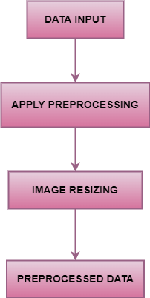

## Fig: 4.2: Dataset Pre-processing

* + 1. ***Dataset Augmentation***

In data analysis, data augmentation refers to approaches for increasing the amount of data by adding slightly changed copies of current data or creating new synthetic data from existing data. It acts as a regularize and helps reduce overfitting when training a machine learning model. It is closely related to oversampling in data analysis. Machine learning applications are quickly broadening and increasing, particularly in the deep learning arena. Techniques for data augmentation could be beneficial in addressing the problems that the artificial intelligence industry is facing. Data augmentation can assist improve the performance and results of machine learning models by producing new and varied cases to train datasets A machine learning model performs better and is more accurate when the dataset is large and sufficient. Data collection and labelling for machine learning models can be time-consuming and costly. When the dataset is large and sufficient, a machine learning model performs better and is more accurate. Data collection and labelling can be time-consuming and costly for machine learning models. Companies can lower these operational costs by transforming datasets using data augmentation techniques. Cleaning data is one of the phases in creating a data model, and it is required for high accuracy models. However, if data cleaning reduces representability, the model will be unable to make accurate predictions for real-world inputs. Machine learning models can be made more robust via data augmentation approaches, which create variances that the model might encounter in the actual world. Image data augmentation is perhaps the most well-known type of data augmentation and involves creating transformed versions of images in the training dataset that belong to the same class as the original image. Transforms include a range of operations from the field of image manipulation, such as shifts, flips, zooms, and much more.

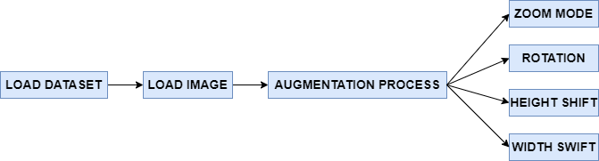

## Fig: 4.3: Dataset Augmentation

* + 1. ***Deep Learning Algorithm training***

After dataset pre-processing and dataset augmentation, it will be fed for training with the efficient deep learning algorithms. The algorithms such as GoogLeNet and Resnet can be compared for increasing the performance of the system to predict the presence of disease.

* + - 1. *GoogLeNet:*

GoogLeNet is a 22-layer deep convolutional neural network developed by Google researchers as a variation of the Inception Network, a Deep Convolutional Neural Network. Computer vision problems such as picture categorization and object recognition were accomplished using the GoogLeNet architecture presented at the ImageNet Large-Scale Visual Recognition Challenge 2014 (ILSVRC14).

The GoogLeNet architecture solved most of the problems that large networks faced, mainly through the Inception module's utilization. The Inception module is a neural network design that uses convolutions with multiple filters to identify features at different scales and uses dimensional reduction to lower the computing cost of training a large network. There are a total of 9 inception modules in the GoogLeNet architecture, which comprises of 22 layers (27 levels including pooling layers).

The GoogLeNet architecture was established with the goal of being a powerhouse with more computational efficiency than some of its predecessors or similar networks at the time. One of the ways the GoogLeNet achieves efficiency is by reducing the input image

while maintaining key spatial information. The first convolution layer uses a filter (patch) size of 7x7, which is relatively large compared to other patch sizes within the network. This layer's primary purpose is to immediately reduce the input image, but not lose spatial information by utilizing large filter sizes. The second convolution layer has a depth of two and leverages the 1x1 convolution block, which as the effect of dimensionality reduction. Dimensionality reduction through 1x1 convolution block allows the decrease of computational load by lessening the layers' number of operations.

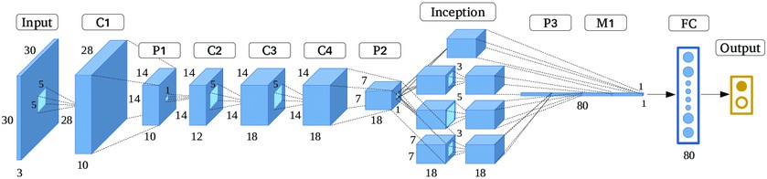

## Fig: 4.4: GoogLeNet architecture

* + - 1. *GoogLeNet Modified*
         1. Average pooling 2D layer.
         2. Convolution 2D layer.
         3. Flatten layer.
         4. Dense layer.
         5. Dropout layer.
      2. *ResNet:*

ResNet is one of the most widely used and successful deep learning models to date. The introduction of these Residual blocks alleviated the challenge of training very deep networks, and the ResNet model is built up of these blocks.

The introduction of these Residual blocks alleviated the challenge of training very deep networks, and the ResNet model is built up of these blocks. The architecture is inspired on VGG-19 and has a 34-layer plain network to which shortcut and skip connections are added. The design is then converted into a residual network by skipping connections or residual blocks. Because the CNN blocks are used several times in the ResNet design, let's develop a CNN block class that accepts input and output channels. After each convolution layer, there is a batchnorm2d. Then construct a ResNet class that takes a number of blocks, layers, picture channels, and classes as input. The benefit of including this type of skip connection is that if any layer degrades architecture performance, it will be skipped by regularization. As a result, very deep neural networks can be trained without the issues caused by vanishing/exploding gradients.

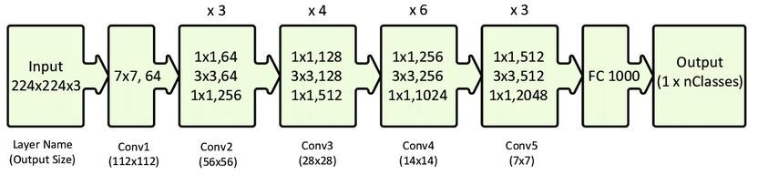

## Fig: 4.5: ResNet architecture

* + - 1. *ResNet Modified:*
         1. Fourth block is added.
         2. Batch Normalisation.
         3. Activation Layer.
         4. Convolution layer.

## Comparison of algorithm

In classification, accuracy and precision are two important evaluation parameters. Accuracy is the proportion of the total number of predictions that were correct. It can be obtained by the sum of true positive and true negative instances divided by 100.And Precision is fraction of true positive and predicted yes instances. The formula of Accuracy and Precision are given below:



After applying the Deep Learning algorithms, it will validate and evaluate the datasets. The accuracy will be compared for both the algorithms to determine the best accurate algorithm.

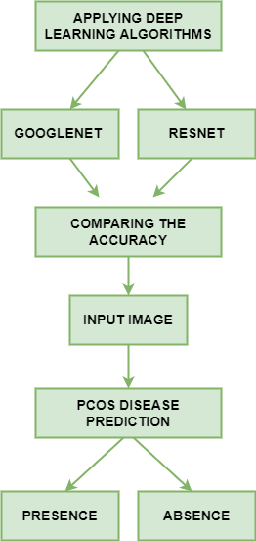

## Fig: 4.6: Comparison of algorithm

* + 1. ***Prediction of disease***

The main objective is to predict the prediction efficiency that would be beneficial for the patients who are suffering from PCOS disease and the percentage ratio will be reduced. Based on the accuracy comparison, an image will be given as input to diagnose the presence of PCOS disease. Predicting it early will lead to effectively save the patient from facing various risk factors.

* 1. SOFTWARE DESCRIPTION

The aim of the Software Requirement Specification is to create the analysis task specification as well as to establish complete information about the requirement, behavior, and other constraints such as functional performance. The Software Requirement Specification's major goal is to fully explain the technical requirements for the software product in a clear and straightforward manner.

## Visual Studio

Microsoft Visual Studio is utilized as an IDE in this project. Visual Studio Code blends the ease of use of a source code editor with advanced developer features such as IntelliSense code completion and debugging. To begin with, it's an editor who gets out of our way. We spend less time dealing with our surroundings and more time executing on our ideas because to the pleasantly frictionless edit-build-debug cycle. Visual Studio Code is available for macOS, Linux, and Windows, allowing us to get started quickly regardless of platform. Visual Studio Code's core feature is a lightning-fast source code editor, which is ideal for day-to-day use. In VS Code, which supports hundreds of languages, syntax highlighting, bracket matching, auto-indentation, box selection, snippets, and more are all available. Because of intuitive keyboard shortcuts, easy modification, and community-contributed keyboard shortcut mappings, we can easily explore our code. We'll often benefit from tools that understand more code than just blocks of text when doing serious coding. IntelliSense code completion, sophisticated semantic code understanding and navigation, and code refactoring are all included into Visual Studio Code. When the coding becomes difficult, the difficult becomes debugging. We made it happen since debugging is generally the one feature that

developers miss the most in a lighter development experience. We can step through source code, check variables, view call stacks, and run commands in the console with Visual Studio Code's interactive debugger. VS Code also connects with build and scripting tools to help you complete typical tasks faster. VS Code now supports Git, allowing us to interact with source control without having to leave the editor, including examining pending change diffs. Customize every feature to our desire and add as many third-party extensions as we want. VS Code changes with us, and we encourage us to personalize our experience to our own requirements. While most situations work "out of the box" with no configuration, we encourage us to tailor our experience to our own requirements. VS Code is powered by the same underlying technologies as Visual Studio and includes enhanced built-in support for Node.js programming, including JavaScript and TypeScript. JSX/React, HTML, CSS, SCSS, Less, and JSON are all well-represented in Visual Studio Code. Visual Studio Code integrates the finest of web, native, and language-specific technology in its architecture. VS Code uses Electron to integrate web technologies like JavaScript and Node.js with native app speed and flexibility. The same industrial-strength HTML-based editor that powers the "Monaco" cloud editor, Internet Explorer's F12 Tools, and other projects is used in VS Code.

## Python

Python is employed as a programming language for development in this project. Python is a high-level object-oriented programming language with built-in dynamic semantics that is mostly used for web and app development. It has a lot of appeal in the field of Rapid Application Development since it allows for dynamic type and binding. Python is a straightforward language to learn because it has a unique syntax that emphasizes readability. Python code is significantly easier to read and translate than code written in other languages. As a result, programmed maintenance and development costs are reduced since teams can collaborate without severe language and experience barriers. Python also supports the usage of modules and packages, allowing applications to be developed in a modular fashion and code to be reused across multiple projects. Once a user has created a module or package, it may be scaled for usage in other projects,

and importing and exporting these modules is simple. One of Python's most appealing features is that both the standard library and the interpreter are freely available in binary and source form. Python and all of the essential tools are available on all main platforms, therefore there is no exclusivity. As a result, it's an appealing solution for developers who don't want to be concerned about large development costs.

# CHAPTER – 5 RESULTS AND DISCUSSION

* 1. RESULTS OBTAINED

To begin, we can divide our project into modules of implementation that have already been completed. The process of gathering Polycystic Ovarian Disease (PCOD) ultrasound picture datasets is known as dataset collection. The dataset has been collected for the project and the below Fig:5.1 can be seen as follows:

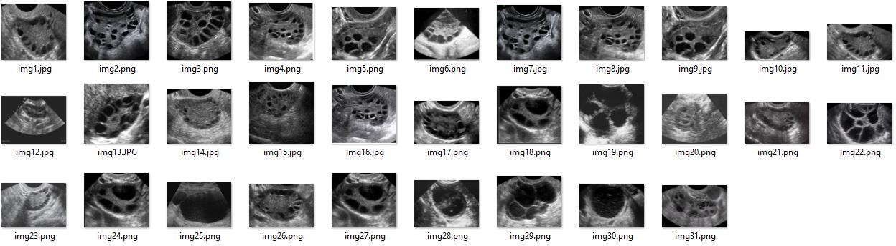

## Fig: 5.1: Dataset Collected

These datasets are then augmented to increase the dataset size and the below Fig:

* 1. can be seen as follows:

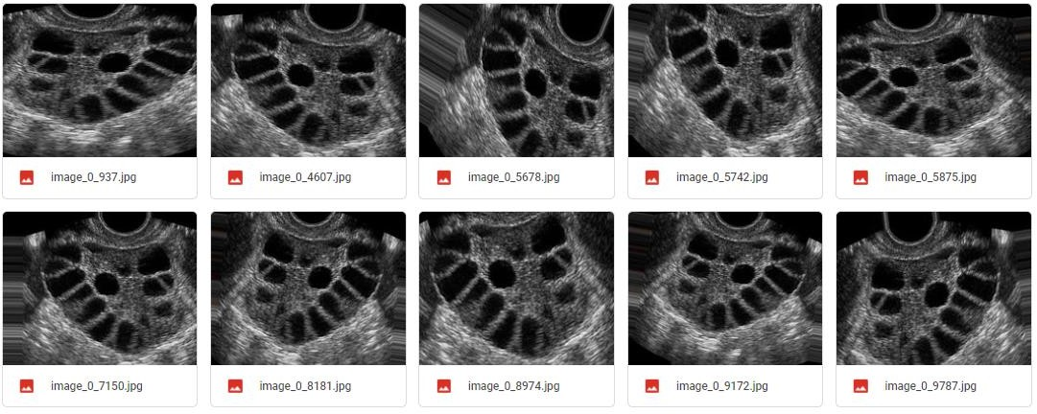

## Fig: 5.2: Dataset Augmentation

Then these datasets are pre-processed from convert the images into required size format so that it can be made ready for training with the model. There are three pre- processing techniques used for image resizing.

Simple Pre-processing:

Pre-processing is the transformation applied to the datasets before giving as an input to the algorithm. It is technique which converts raw data into a clean dataset suitable for the algorithm being used. The results of different pre-processing techniques can be seen in the following Fig: 5.3

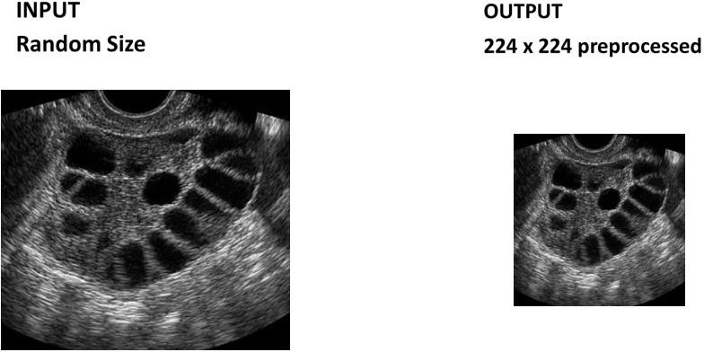

***Fig: 5.3: Simple Pre-processing***

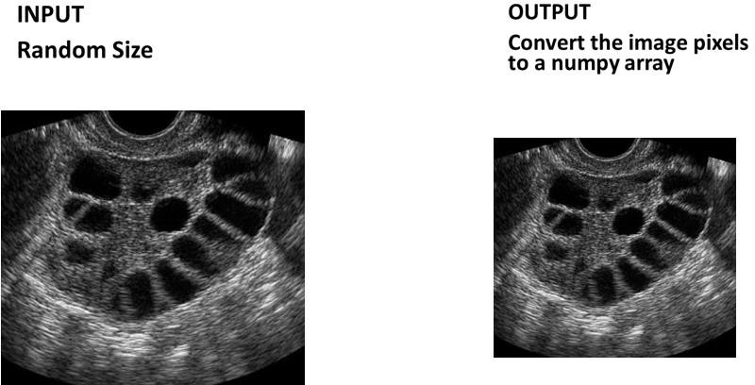

***Fig: 5.4: Image to Array Pre-processing***

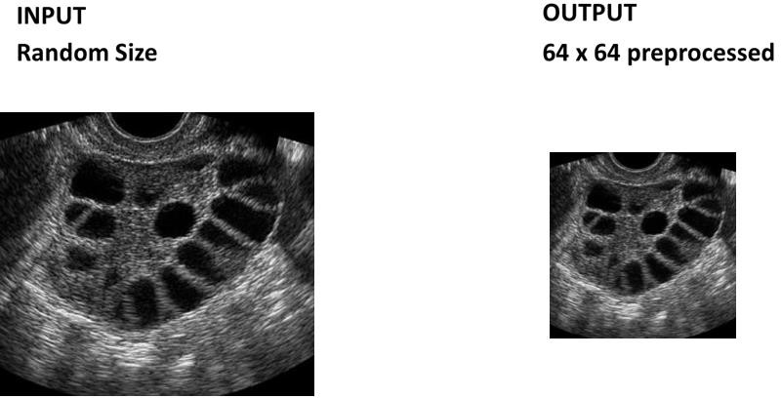

***Fig: 5.5: Aspect Aware Pre-processing***

After pre-processing, training is performed using deep learning algorithms. The first algorithm used for training is ResNet and the results obtained can be seen below. The below Fig: 5.6 shows the ResNet Model classification report.

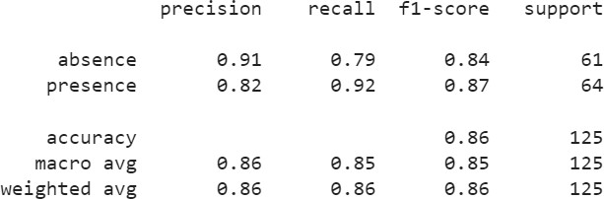

## Fig: 5.6: Classification report of ResNet model

The below Fig: 5.7 shows the training and validation loss of ResNet Model.

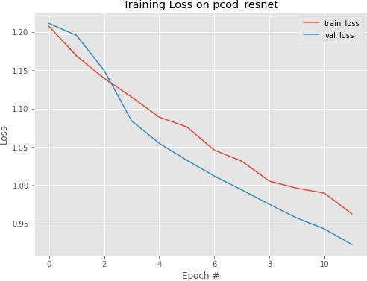

## Fig: 5.7: Training and validation loss graph

The below Fig: 5.8 shows the training and validation accuracy of ResNet Model.

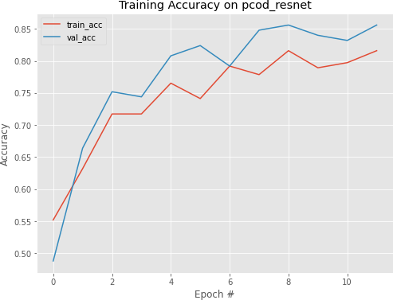

## Fig: 5.8: Training and validation accuracy graph

The second algorithm used for training is Modified ResNet and the results obtained can be seen below. The below Fig: 5.9 shows the Modified ResNet Model classification report.

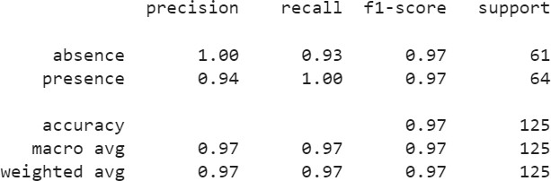

## Fig: 5.9: Classification report of Modified ResNet model

The below Fig: 5.10 shows the training and validation loss of Modified ResNet Model.

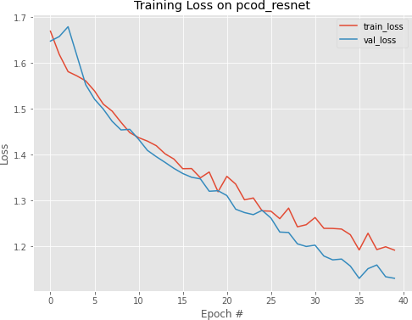

## Fig: 5.10: Training and validation loss graph

The below Fig: 5.11 shows the training and validation accuracy of Modified ResNet Model.

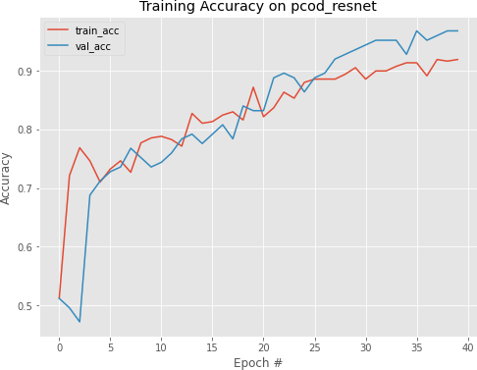

## Fig: 5.11: Training and validation accuracy graph

The third algorithm used for training is GoogLeNet and the results obtained can be seen below.

The below Fig: shows the GoogLeNet Model classification report.

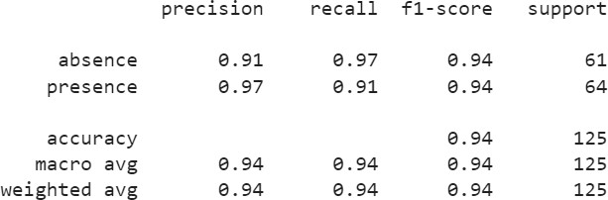

## Fig: 5.12: Classification report of GoogLeNet model

The below Fig: 5.13 shows the training and validation loss of GoogLeNet Model.

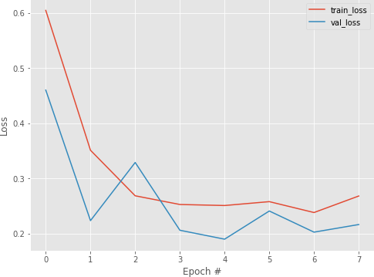

## Fig: 5.13: Training and validation loss graph

The below Fig: 5.14 shows the training and validation accuracy of GoogLeNet Model.

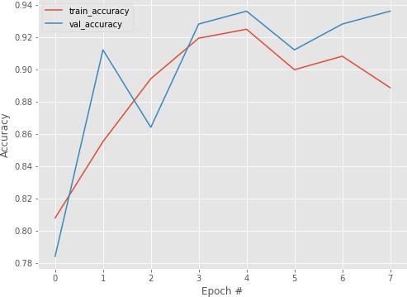

## Fig: 5.14: Training and validation accuracy graph

The fourth algorithm used for training is Modified GoogLeNet and the results obtained can be seen below.

The below Fig: 5.15 shows the Modified GoogLeNet Model classification report.

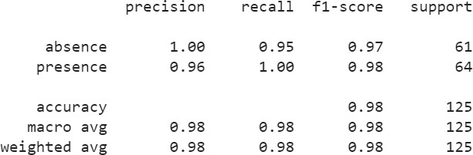

## Fig: 5.15: Classification report of Modified GoogLeNet model

The below Fig: 5.16 shows the training and validation loss of Modified GoogLeNet Model.

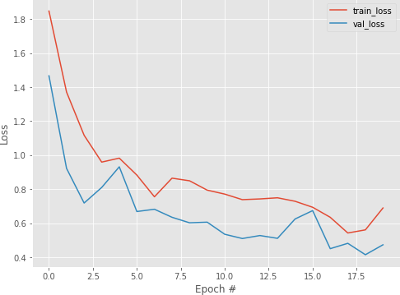

## Fig: 5.16: Training and validation loss graph

The below Fig: 5.17 shows the training and validation accuracy of Modified GoogLeNet Model.

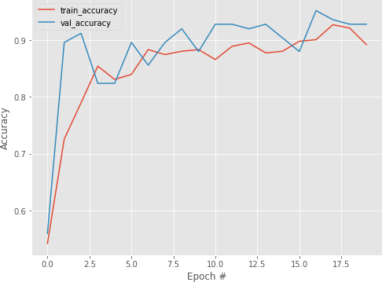

## Fig: 5.17: Training and validation accuracy graph

The below Fig: 5.18 shows the absence of Polycystic ovary disease (PCOD) detection.

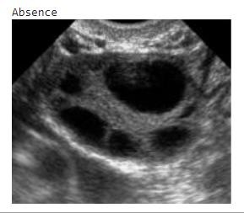

## Fig: 5.18: Absence of PCOD detection

The below Fig: 5.19shows the presence of Polycystic ovary disease detection.

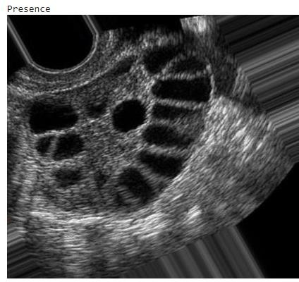

***Fig: 5.19: Presence of PCOD detection***

1.02

For Presence of PCOS

1

0.98

0.96

0.94

0.92

0.9

Accuracy

Recall

Precision

F1 Score

Axis Title

Modified GoogleNet Modified ResNet

Percentage

***Fig: 5.20: Comparison between accuracy, recall, precision and F1 score of modified GoogLeNet and modified ResNet***

# CHAPTER – 6 SUMMARY & CONCLUSION

* 1. SUMMARY

In this project, the trained model has successfully predicted the Polycystic Ovary Disease (PCOD) disease. In the existing system, KNN algorithm is used and the accuracy depends on the quality of the data and the system only focused on follicles determination to diagnose the PCOS disease. In the proposed system, we have overcome the disadvantages of the existing system to easily determine the prediction of Polycystic Ovary Disease (PCOD) disease at the earliest. Also, it saves patient from serious health issues and provides a practical application to hospitals.

* 1. CONCLUSION

The project has been successfully implemented to predict the presence of the PCOS disease from the ultrasonic scanned images at an early stage using the deep learning algorithms and provide prior measures to avoid the disease. The algorithms such as GoogLeNet and ResNet are used to predict the outcome whether the person is PCOS disease effected based on the input image can be compared for increasing the performance of the system to predict the presence of disease. This also help in providing efficient treatment in a most cheap way and eventually reduce the time required for finding the PCOS disease. There is a lot of room for advancement in technology because diagnosis can be done in a variety of ways.

* 1. FUTURE WORK

In the coming future, we review the application of the PCOS disease determine technology in the healthcare field and it can promote for detecting the disease with more accuracy. In medical field they have more chance to develop or convert this project in many ways. Thus, this project has an efficient scope in coming future where manual predicting can be converted to computerized production in a cheap way.

# REFERENCE

1. Bharati S, Prajoy Podder, M. R. Hossain Mondal- Diagnosis of Polycystic Ovary Syndrome Using Machine Learning Algorithms- IEEE- June 2020.
2. Chunyu Wang; Junling Guo; Ning Zhao; Yang Liu; Xiaoyan Liu; Guojun Liu; Maozu Connor Shorten and Taghi M. Khoshgoftaar-A survey on Image Data Augmentation for Deep Learning-Journal of Big Data-2019.
3. Dipamoni Morang, Pankaj Chasta, Kaushal K. Chandrul-Polycystic Ovary Syndrome (PCOS)-IJTSRD-Vol.3 Issue-4, June 2019.
4. Guo, “A Cancer Survival Prediction Method Based on Graph Convolutional Network”, IEEE Trans Nanobioscience [2020 Jan;19]
5. Kiruthika. V, S Sathiya and M.M. Ramya- Machine Learning based ovarian detection in ultrasound images-Int. J. Advanced Mechatronic Systems-Vol. 8, 2020.
6. Micha Feigin; Daniel Freedman; Brian W. Anthony, “A Deep Learning Framework for Single-Sided Sound Speed Inversion in Medical Ultrasound”, IEEE Transactions on Biomedical Engineering [Vol no: 67, 2020]
7. Nikhil S. Narayan; Pina Marziliano; Jeevendra Kanagalingam; Christopher G. L. Hobbs, “Speckle Patch Similarity for Echogenicity-Based Multiorgan Segmentation in Ultrasound Images of the Thyroid Gland”, IEEE Journal of Biomedical and Health Informatics [Vol no: 21, 2017]
8. Nilofer. N. S and Dr. Ramkumar.R, “Follicles Classification to Detect Polycystic Ovary Syndrome Using Glcm and Novel Hybrid Machine Learning”, Turkish Journal of Computer and Mathematics Education [Vol no: 12, 2021]
9. Priyanka R Lele and Anuradha D. Thakare- Comparative Analysis of Classifiers for Polycystic Ovary Syndrome Detection using Various Statistical Measures-IJERT- Vol.9 Issue 03, March 2020.
10. Rachana B, R. Sunitha- Detection of PCOS using follicle recognition technique- Global Transitions Proceedings-Vol.2 Issue 2, Nov 2021.
11. Shekoofeh Azizi; Sharareh Bayat; Pingkun Yan; Amir Tahmasebi; Jin Tae Kwak; Sheng Xu; Baris Turkbey, “Deep Recurrent Neural Networks for Prostate Cancer Detection: Analysis of Temporal Enhanced Ultrasound”, IEEE Transactions on Medical Imaging [Vol no: 37, 2018]
12. Sumathi M, P Chitra, R Sakthi Prabha and Srilatha K-Study and detection of PCOS related diseases using CNN-ICRIET 2020.
13. Vikas B, Radhika Y, Vineesha K, “Detection of Polycystic Ovarian Syndrome using Convolutional Neural Networks”, International Journal of Current Research and Review [Vol no: 13, 2021]
14. Wenfeng Song, Shuai Li, Ji Liu, Hong Qin, Bo Zhang, Shuyang Zhang, and Aimin Hao, “Multi-task Cascade Convolution Neural Networks for Automatic Thyroid Nodule Detection and Recognition”, IEEE JOURNAL OF LATEX CLASS FILES [Vol no: 14, 2015]
15. Xiangbin Liu, Liping Song, Shuai Liu and Yudong Zhang-A Review of Deep- Learning-Based Medical Image Segmentation Methods-Sustainability- Jan, 2021.